British public schools

Read the texts.
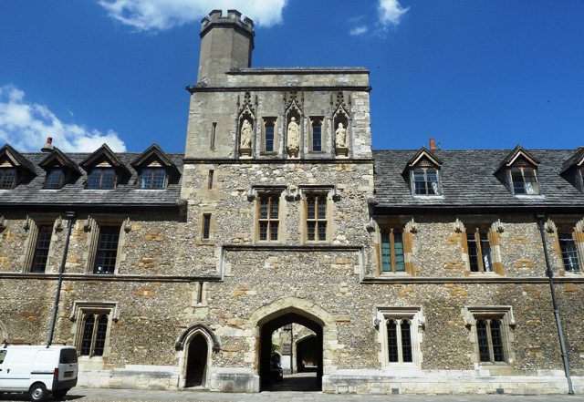
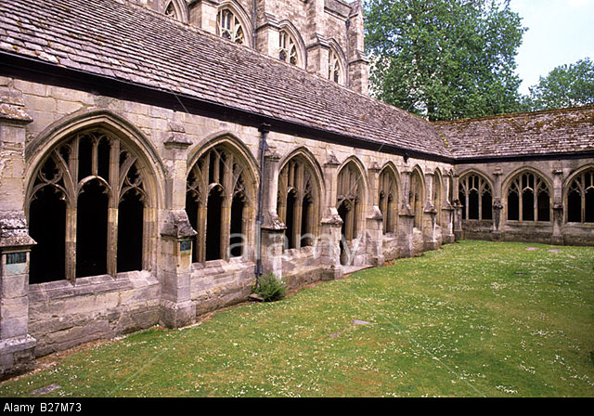
Eton College is one of England’s most eminent public (meaning private) schools. It was founded by King Henry VI in 1440. Eton College is a single-sex boys’ public school which educates 1,300 students between the ages of 13 and 18. Students are selected by competitive examination, live at the school and wear a uniform of black tailcoat and waistcoat, a white tie and pin striped trousers. They generally come from the country’s wealthiest and most prestigious families – 25% of Eton’s pupils have aristocratic surnames. One year costs £30,000 and a scholarship is awarded to gifted children. Sport is a very important element in the students’ education: they do two hours of sport every day!

Winchester College is one of the oldest public schools in the country. It was founded in 1382 and is housed in restored medieval and 17th century buildings.

Put the words in the correct order to make sentences.
- Eton College / England’s / eminent / is / one / public / most / of / schools
- Eton College / founded / King / by / in / 1440/ was / Henry VI
- Eton College / single-sex / is / boys’/ a / public / school
- students / between / ages / the / 1,300 / of / 13 / 18 / and / attend / Eton College
- Eton College / very / is / expensive
- have / 25% / surnames / of / pupils / aristocratic / Eton’s
- Students / every day / do / of / sport / hours / two
- Winchester College / 1382 / in / founded / was

