The Edinburgh Festival
Read the text

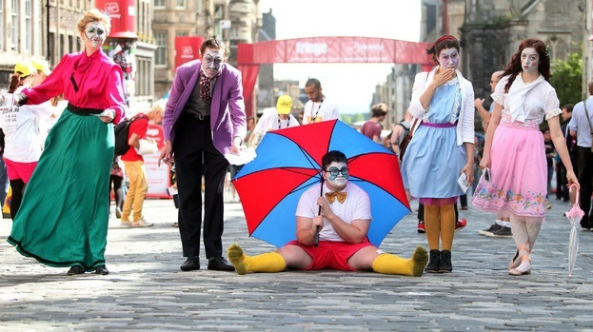
The Edinburgh Festival is one of the biggest arts festivals in the world. Every year in August and September there are lots of concerts, films, comedy shows, drama performances, street theatre, spectacular fireworks and musical bands. These events attract many people and performers from all over the world and take place in different areas of the city. So the best way to see and enjoy as many performances as possible is to put your old shoes on (indossare scarpe comode).

“Castaway 2000” – the major BBC TV series
Read the text

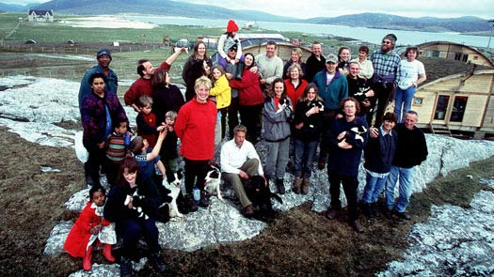
In the year 2000 the BBC made a programme called Castaway. It was a ‘social experiment’: 36 men, women and children were put on a remote Scottish island called Taransay. The participants had to live and work together in order to survive for a year. The BBC filmed the progress of the participants. Only 29 participants lasted the whole 12 months.
The series was more a documentary than a reality television show because the aim was to build a community rather than to select a winner. In fact, there was no winner and no prize on offer at the end of the year-long experience.

These sentences contain some mistakes. Can you find them? Rewrite the sentences with the correct information.

- The Edinburgh Festival is one of the biggest music festivals in the world.
- The Edinburgh Festival takes place in July and August.
- The Edinburgh Festival attracts British people and performers.
- The Edinburgh Festival takes place in different Scottish cities.
- “Castaway” wasn’t a social experiment.
- Only 36 participants lasted the whole 12 months.
- The series was more a reality television show than a documentary because the aim was to select a winner.

