Modern biotechnology

Read the text.
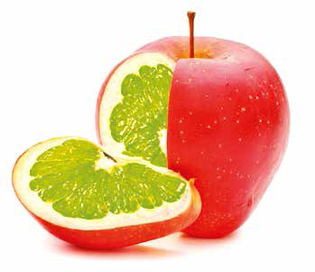
Modern biotechnology
Biotechnology is an integral part of human life. Scientists use the term traditional biotechnology when they refer to the natural processes used to produce bread, cheese, wine, etc., and the natural reproduction of plants and animals over years, decades or even centuries. Modern biotechnology, by contrast, refers to all the genetic manipulations which modify, in a short time, the genetic content of living cells or an entire organism. For example, a desired gene can be taken from any living organism and inserted into an entirely different species. The new organism produced is called transgenic (trans comes from Latin. It means across, beyond).
Biotechnology, which is advancing at a very rapid pace, includes genetic engineering whose techniques may also offer the possibility of correcting certain hereditary disorders, improving human and veterinary medicine, diagnostics, genetically-modified food, etc.
The commercial sale of genetically modified foods began in the mid-1990s. They include many products such as corn, wheat, soya beans, rice, sugar beets, honey, butter, margarine, oils, mayonnaise, ketchup, meat, tomatoes, potatoes, broccoli, beans, peas, apples, bananas, etc.

Genetically-modified food
GM (Genetically-modified) foods or GM organisms refer to crops, plant vegetables and fruit that have been created quickly and artificially in the laboratory to improve desired traits. This means that their genetic material (DNA) has been altered in a way that does not occur naturally. Such artificially modified foods are a source of unresolved controversy concerning their safety and the possibly negative impact on human health and the environment.

(Slightly adapted from www.who.int/foodsafety/publications/biotech/.../en; http://allaboutbiotechnology.blogspot.it/2008/06/traditional-biotechnology-vs-new.html and https://en.wikipedia.org/wiki/Biotechnology)

Match the two parts of the sentences.

a Traditional biotechnology refers to the natural processes used to produce bread, cheese, wine, etc.,

b Modern biotechnology refers to all the genetic manipulations which modify

c Genes can be transferred between species that are distantly related or

d Genetic engineering technology is

e GM foods refer to crops, plant vegetables and fruit that have been created quickly and artificially in the

f Gregor Johann Mendel is considered
1 the genetic content of living cells or an entire organism.

2 the “father of modern genetics”.

3 useful for the cure of hereditary disorders.

4 laboratory to improve desired traits.

5 not related at all.

6 and the natural reproduction of plants and animals over years, decades or even centuries.

