Snowdonia National Park
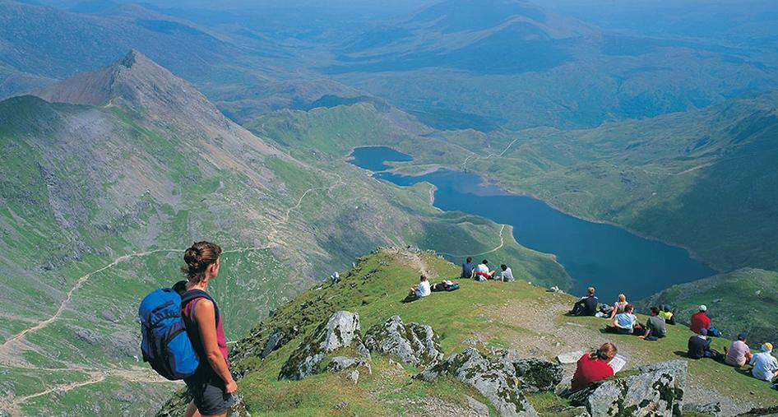

Snowdonia National Park is situated in north Wales. It was created in 1951 as the third National Park of Britain. Covering 2,130 km² of diverse landscapes, it is the largest National Park in Wales. Over 26,000 people live within the Park and more than 60% of them speak Welsh. Its landscape is amazing and varied with 37 km of coastline, mountains (Snowdon is the highest peak in England and Wales), valleys, lakes (Llyn Tegid is the largest natural lake in Wales), waterfalls, forests and some of the world’s oldest rocks (there are rocks which are over 400 million years old) and minerals, including slate (ardesia) and copper (rame).
The area is also famous for its archaeological remains, picturesque villages, beautiful castles, farm houses, museums, wildlife and national nature reserves, of course.
Every year, Snowdon attracts about 400,000 walkers and around 100,000 visitors reach the summit by little steam trains, which are a very special way of enjoying the scenery. Between 7 and 9 million people visit Snowdonia National Park every year.
By the way, legend has it that Snowdon is the burial place of the fierce giant Rhita Gawr who was killed by King Arthur on the top of the mountain, after an epic battle!

Decide if the following sentences are True (T) or False (F). True False
1) Snowdonia National Park is situated in north England.
2) More than 26,000 people live within the Park and over 60% of them speak Welsh.
3) Snowdonia’s landscape is unimpressive and varied.
4) Mount Snowdon is the highest peak in England.
5) In Snowdonia National Park, there are lakes, mountains, valleys, waterfalls, forests, a lovely coastline and some of the world’s oldest rocks and minerals.
6) Snowdonia is also famous for its villages, harbours and sandy beaches.
7) Every year, Snowdon attracts about 400,000 walkers and around 100,000 visitors reach the summit by little steam trains.

