The inter-war years

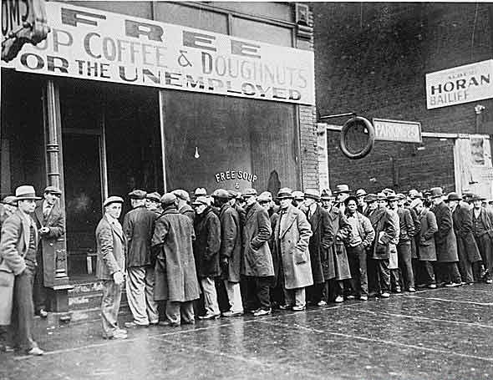
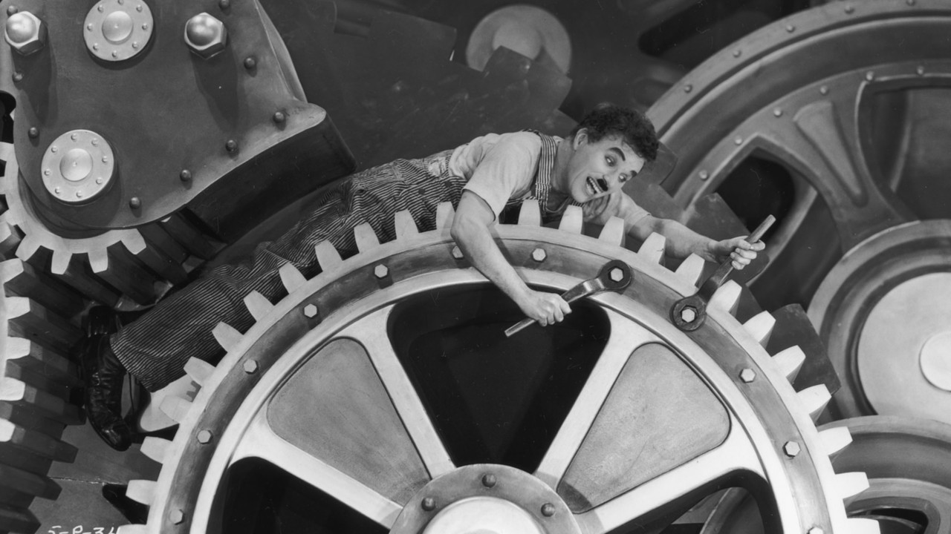

Read the text.

Optimism marked the 1920s
After the First World War people hoped for a better future. Optimism and progress in technology and communication marked the 1920s. It was the decade of the first transatlantic flight, the movie, the radio and mass-produced vehicles. The American car industrialist Henry Ford expanded the assembly-line system of mass production and improved the efficiency of his workers by adopting a new method of construction of his cars, which forced workers to work at a certain pace with very repetitive motions. Increased productivity resulted in workers receiving better wages, becoming good consumers and buying things through credit.

Economic and political problems
People’s early hopes for a better world changed with the difficulties that the victorious countries faced in rebuilding Europe and world stability, and the severe economic and political problems which some European nations such as Germany and Italy experienced after the war. Many people lost faith in democratic governments and turned to extremist political groups. In Italy, Benito Mussolini of the National Fascist Party became Prime Minister and set up the world’s first fascist government in 1922. In Germany, the Nazi Party, under the leadership of Adolf Hitler, became a significant political force in the late 1920s.

The consequences of the Wall Street Crash
Things got worse with the financial and economic crisis of 1929 in the United States (the Wall Street Crash) whose impact on countries all over the world was devastating. In Europe, high levels of unemployment, growing poverty, social and cultural insecurity, and growing fear of communism reinforced fascism in Italy, made the fortunes of Hitler, who was elected Chancellor of Germany in 1933, and helped Francisco Franco bring his own version of fascism to Spain. In Asia, Japan’s rulers were determined to expand Japan’s territory, occupy China and exploit its resources.
The financial and economic crisis and its social and political effects led to hostility among states and the end of peace. Within twenty years of the Treaty of Versailles, the world was at war again!

Choose the correct option.
1 After the First World War people
A were optimistic.
B were pessimistic.
C worried about the future.

2 Progress in technology and communication marked

A the First World War.
B the 1920s.
C the end of the First World War.

3 The American car industrialist Henry Ford

A didn’t revolutionise the car industry.
B invented the factory system.
C revolutionised the car industry.

4 Many people lost faith in democratic governments

A because politicians were dishonest.
B because of severe economic and political problems.
C because there weren’t many important political parties.

5 In Italy, Benito Mussolini set up the world’s first fascist government

A in 1922.
B in the late 1920s.
C in the early 1920s.

6 In Germany, the Nazi Party became a significant political force

A in the early 1920s.
B in the late 1920s.
C in 1922.

7 The financial and economic crisis of 1929

A didn’t affect European countries.
B didn’t affect the United States.
C affected countries all over the world.

8 The financial and economic crisis of 1929 and its social and political effects

A led to hostility among states.
B led to peace among states.
C led to cooperation and solidarity among states.

