The University of Oxford

Read the text.

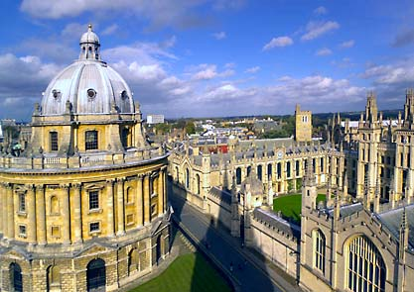
Oxford is very famous for its university. At Oxford University there are 38 colleges with many old and new buildings located all over the city centre with more than 22,000 students. Oxford is also home to the largest university library system in the UK and six fascinating museums such as the Ashmolean Museum, which houses a large collection of art and antiquities ranging back over four thousand years. Here you can see the works of such famous artists as Michelangelo, Leonardo da Vinci, Turner and Picasso. Oxford has also got many beautiful parks and gardens in which to relax.
Famous people have studied at Oxford University. Among these there are writers, poets, philosophers, historians, scientists, economists, British Prime Ministers, international leaders, Nobel Prize winners, Archbishops of Canterbury, actors, film-makers, etc.
This is a short list of famous Oxonians, that is people who have studied at the University of Oxford. Thomas More, John Donne, Thomas Hobbes, John Locke, Samuel Johnson, Jonathan Swift, Lewis Carroll, Eglantyne Jebb, Percy Bysshe Shelley, Oscar Wilde, J R R Tolkien, Indira Gandhi, Margaret Thatcher, Tony Blair, Bill Clinton and Tim Berners-Lee – the inventor of the World Wide Web!

Say if these sentences are True (T) or False (F).
True False
- At Oxford University there are 38 colleges and more than 22,000 students.
- At Oxford University there is the largest university library system in the world.
- The Ashmolean Museum houses a large collection of art and antiquities
ranging back over four thousand years, and the works of famous artists.
- The term Oxonians refers to people who lived in Oxford.
- Tim Berners-Lee studied at the University of Oxford.

